**Bugs Report**

Web Application:

|  |  |
| --- | --- |
| BUG ID | TITLE |
| BUG-ID | Misalignment of “Enter Your Organization Industry Field” |
| 02 | "Other" Field Does Not Reset in "How Did You Hear About Us?" Section |
| 03 | Cursor Moves at the beginning on Eye Icon Click |
| 04 | Missing Validation Highlighting and Messages |
| 05 | Form Refresh on Common Password Entry |
| 06 | Invalid Character Input in Name Fields |
| 07 | Invalid Input in Organization Name |
| 08 | Misaligned Country Code and Name |
| 09 | Invalid Input in Organization Industry, Role, and Hear About Us Fields |
| 10 | Field Accepting Space as Input Causes Invalid Validation Message |
| 11 | Keyboard Navigation Issue with Communication Channels |
| 12 | Unauthorized Error on Language Change |
| 13 | Notifications Displayed in Bottom Left Corner |

Mobile Application:

|  |  |
| --- | --- |
| BUG ID | TITLE |
| BUG-14 | Contact Search Fails to Display Matching Results |
| BUG-15 | Language Name in Combo Box List is Cropped and Overlapping |
| BUG-16 | Language "PyccKᴎᴎ" Not Displayed in Search Filter |
| BUG-17 | Error: "Something Went Wrong" when Logging into Mobile App After Signup on Web |

**Bug Title:**Misalignment of "Enter Your Organization Industry" Field  
  
**Bug ID:** BUG-01  
**Reported By:** Syed Hassan Anwer  
**Date:** 2024-10-05  
**Environment:**

* Platform: Web
* OS: Windows 10
* Browser: Google Chrome Version 117.0.5938.132 (Official Build) (64-bit)
* Device: Laptop (1366x768 screen resolution)

**Description:**

The "Enter your organization industry" text field is misaligned with the "Industry" dropdown. The text field appears lower than its corresponding label, breaking the overall consistency of the form layout and potentially causing confusion for users when filling out the form.

**Steps to Reproduce:**

1. Open the website on Google Chrome on Windows 10.
2. Navigate to the "Create Organization" page.
3. Observe the alignment between the "Industry" dropdown and the "Enter your organization industry" text field.

**Expected Result:**

The "Enter your organization industry" text field should be aligned horizontally with the "Industry" dropdown field, maintaining visual consistency and an intuitive form layout.

**Actual Result:**

The "Enter your organization industry" text field is misaligned and appears lower than the "Industry" dropdown, creating a visually uneven form layout.

**Severity:** Low

**Priority:** Medium

**Annexure:**

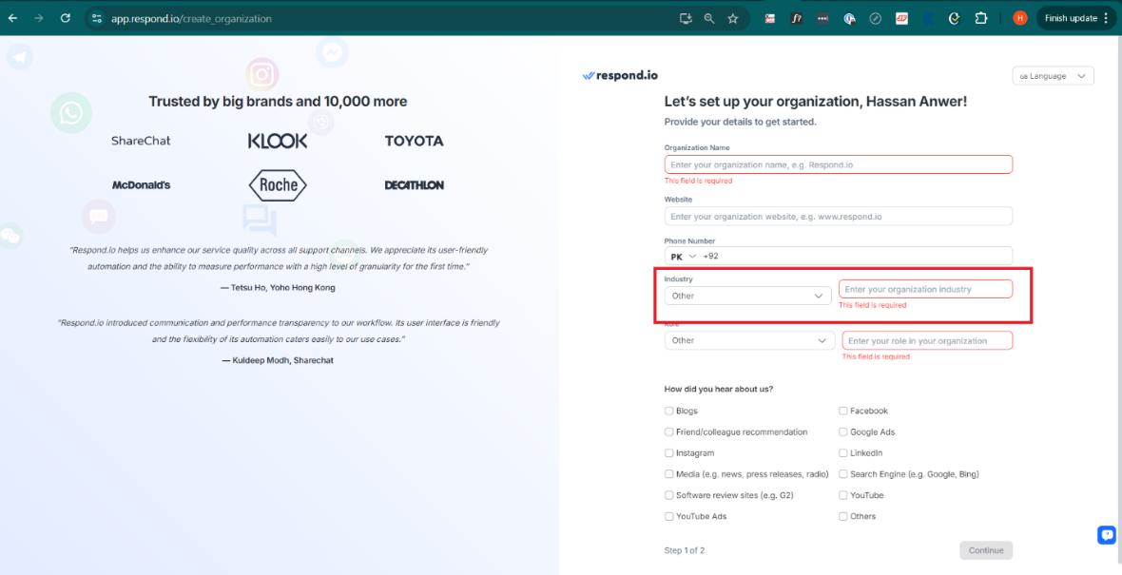

**Bug Title:**

"Other" Field Does Not Reset in "How Did You Hear About Us?" Section

**Bug ID:** BUG -02  
**Reported By:** Syed Hassan Anwer  
**Date:** 2024-10-05  
**Environment:**

* **Platform:** Web
* **OS:** Windows 10
* **Browser:** Google Chrome Version 117.0.5938.132 (Official Build) (64-bit)
* **Device:** Laptop (1366x768 screen resolution)

**Description:**

In the "How did you hear about us?" section of the form, when the user checks the "Others" checkbox and inputs custom text, then unchecks "Others", the custom input field does not reset itself. When the user rechecks "Others", the previously entered text is still visible. This behavior disrupts expected functionality, as the field should clear when "Others" is unchecked.

**Steps to Reproduce:**

1. Open the website on Google Chrome on Windows 10.
2. Navigate to the "Create Organization" page.
3. Scroll down to the "How did you hear about us?" section.
4. Check the "Others" checkbox and enter some custom text in the "Other" field.
5. Uncheck the "Others" checkbox.
6. Recheck the "Others" checkbox.
7. Observe the behavior of the "Other" field.

**Expected Result:**

When the "Others" checkbox is unchecked, the input field should reset, and any previously entered text should be cleared. Upon rechecking the checkbox, the field should be empty, allowing the user to enter new information if needed.

**Actual Result:**

When the "Others" checkbox is unchecked and then rechecked, the previously entered text remains in the "Other" field, which can cause confusion for the user and may lead to incorrect submissions.

**Severity:** Medium

**Priority:** Low

**Bug Title:**Cursor Moves at the beginning on Eye Icon Click

**Bug ID:** BUG-03  
**Reported By:** Syed Hassan Anwer  
**Date:** 2024-10-05  
**Environment:**

* Platform: Web
* OS: Windows 10
* Browser: Google Chrome Version 117.0.5938.132 (Official Build) (64-bit)
* Device: Laptop (1366x768 screen resolution)

**Description:**The cursor moves to the beginning of the password field after clicking the eye icon to toggle password visibility, disrupting the user experience and hindering efficient password management.

**Steps to Reproduce:**

1. Open the website on Google Chrome on Windows 10.
2. Navigate to a page with a password field.
3. Click on the eye icon to toggle password visibility.
4. Observe the cursor's position after clicking the eye icon.

**Expected Result:**The cursor should remain in the same position within the password field after clicking the eye icon.

**Actual Result:**The cursor moves to the beginning of the password field.

**Severity:** Medium  
**Priority:** Medium  
  
**Annexure:**

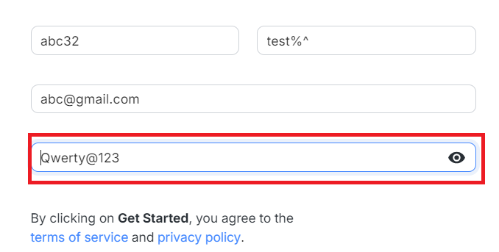

**Bug Title:**Missing Validation Highlighting and Messages

**Bug ID:** BUG-04  
**Reported By:** Syed Hassan Anwer  
**Date:** 2024-10-05  
**Environment:**

* Platform: Web
* OS: Windows 10
* Browser: Google Chrome Version 117.0.5938.132 (Official Build) (64-bit)
* Device: Laptop (1366x768 screen resolution)

**Description:**The form fails to provide clear visual cues and informative error messages when users enter invalid data, leading to confusion and frustration.

**Steps to Reproduce:**

1. Open the website on Google Chrome on Windows 10.
2. Navigate to a form with required fields.
3. Enter invalid data in a required field.
4. Try to submit the form.

**Expected Result:**The form should visually indicate invalid fields and display specific error messages for each issue.

**Actual Result:**Invalid fields might not be highlighted, and error messages might be missing or unclear.

**Severity:** High  
**Priority:** High

**Bug Title:**Form Refresh on Common Password Entry

**Bug ID:** BUG-05  
**Reported By:** Syed Hassan Anwer  
**Date:** 2024-10-05  
**Environment:**

* Platform: Web
* OS: Windows 10
* Browser: Google Chrome Version 117.0.5938.132 (Official Build) (64-bit)
* Device: Laptop (1366x768 screen resolution)

**Description:**The form unexpectedly refreshes or resets when a common password is entered, disrupting the user's workflow and potentially leading to data loss.

**Steps to Reproduce:**

1. Open the website on Google Chrome on Windows 10.
2. Navigate to a form with a password field.
3. Enter a common password (e.g., "Qwerty@123").
4. Try to submit the form.

**Expected Result:**The form should proceed to the next step without any unexpected behavior.

**Actual Result:**The form might refresh or reset.

**Severity:** Medium  
**Priority:** Medium

**Annexure:**

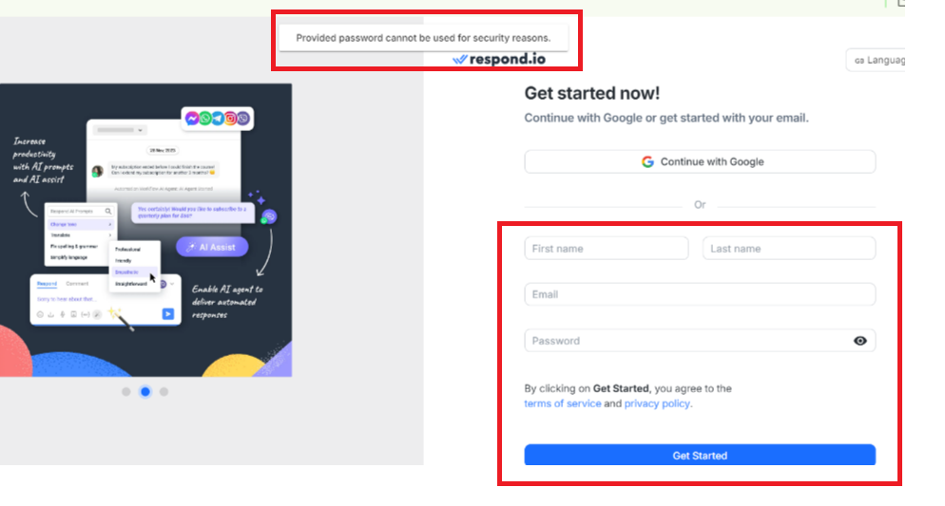

**Bug Title:**Invalid Character Input in Name Fields

**Bug ID:** BUG-06  
**Reported By:** Syed Hassan Anwer  
**Date:** 2024-10-05  
**Environment:**

* Platform: Web
* OS: Windows 10
* Browser: Google Chrome Version 117.0.5938.132 (Official Build) (64-bit)
* Device: Laptop (1366x768 screen resolution)

**Description:**The form allows invalid characters (e.g., special symbols) to be entered in the first or last name fields, potentially leading to data integrity issues.

**Steps to Reproduce:**

1. Open the website on Google Chrome on Windows 10.
2. Navigate to a form with name fields.
3. Enter a special character (e.g., "!") in the first or last name field.
4. Try to submit the form.

**Expected Result:**The form should display an error message indicating that the “input is invalid” or “special characters not allowed”

**Actual Result:**The form might allow invalid characters.

**Severity:** Medium  
**Priority:** Medium

**Annexure:**

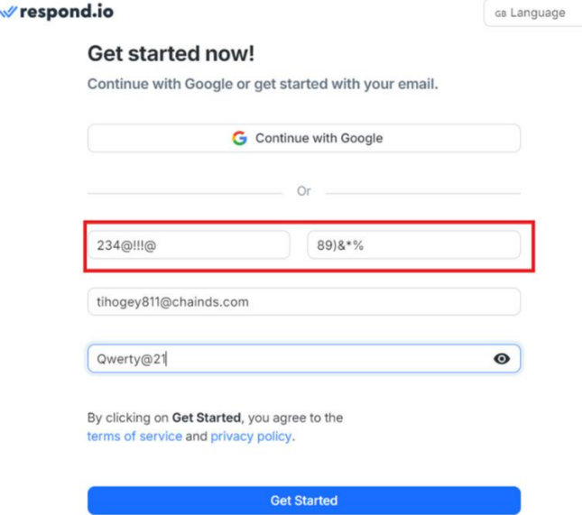

**Bug Title:**Invalid Input in Organization Name

**Bug ID:** BUG-07

**Reported By:** Syed Hassan Anwer  
**Date:** 2024-10-05  
**Environment:**

* Platform: Web
* OS: Windows 10
* Browser: Google Chrome Version 117.0.5938.132 (Official Build) (64-bit)
* Device: Laptop (1366x768 screen resolution)

**Description:**The form allows invalid characters (e.g., special symbols) to be entered in the organization name field, potentially leading to data integrity issues.

**Steps to Reproduce:**

1. Open the website on Google Chrome on Windows 10.
2. Navigate to a form with an organization name field.
3. Enter invalid characters (e.g., special symbols) in the organization name field.
4. Try to submit the form.

**Expected Result:**The form should display an error message indicating that the input is invalid.

**Actual Result:**The form might allow invalid characters.

**Severity:** Medium  
**Priority:** Medium

**Annexure:**

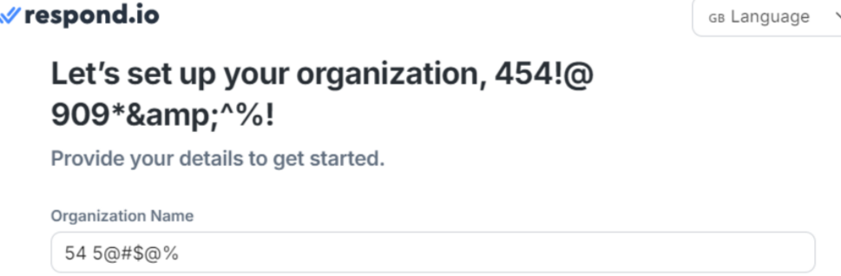

**Bug Title:**Misaligned Country Code and Name

**Bug ID:** BUG-08  
**Reported By:** Syed Hassan Anwer  
**Date:** 2024-10-05  
**Environment:**

* Platform: Web
* OS: Windows 10
* Browser: Google Chrome Version 117.0.5938.132 (Official Build) (64-bit)
* Device: Laptop (1366x768 screen resolution)

**Description:**The country code and country name are not aligned properly in the country selection dropdown, creating a visually unappealing and potentially confusing user experience.

**Steps to Reproduce:**

1. Open the website on Google Chrome on Windows 10.
2. Navigate to a form with a country selection dropdown.
3. Select a country from the dropdown.

**Expected Result:**The country code and country name should be aligned and displayed in a clear and visually appealing manner.

**Actual Result:**The country code and country name might not be aligned properly.

**Severity:** Low  
**Priority:** Medium

**Annexure:**

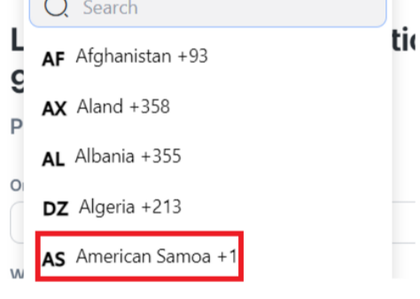

**Bug Title:**Invalid Input in Organization Industry, Role, and Hear About Us Fields

**Bug ID:** BUG-09  
**Reported By:** Syed Hassan Anwer  
**Date:** 2024-10-05  
**Environment:**

* Platform: Web
* OS: Windows 10
* Browser: Google Chrome Version 117.0.5938.132 (Official Build) (64-bit)
* Device: Laptop (1366x768 screen resolution)

**Description:**

The form fails to validate input in the organization industry, role, and hear about us fields, potentially leading to data integrity issues and incorrect data collection.

**Steps to Reproduce:**

1. Open the website on Google Chrome on Windows 10.
2. Navigate to a form with organization industry, role, and hear about us fields.
3. Enter invalid characters or leave fields blank.
4. Try to submit the form.

**Expected Result:**The form should display error messages for invalid input and require all necessary fields to be filled.

**Actual Result:**The form might allow invalid input or might not require all fields to be filled.

**Severity:** Medium  
**Priority:** Medium

**Annexure:**

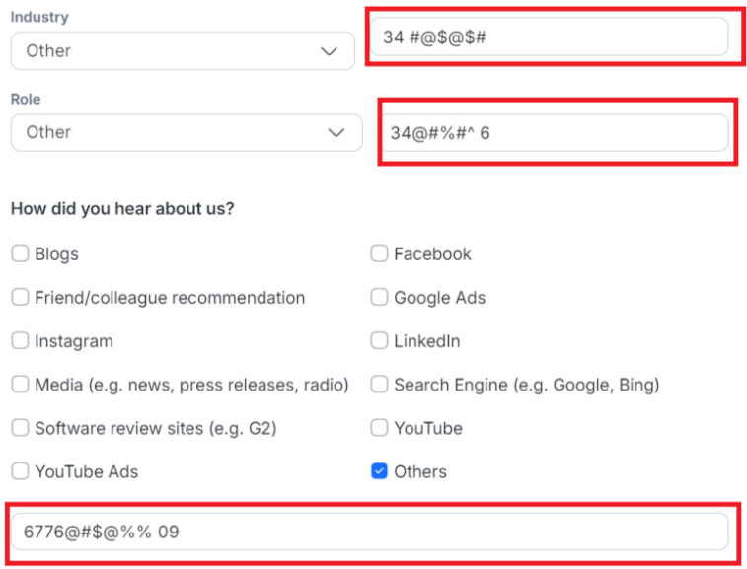

**Bug Title:**  
Field Accepting Space as Input Causes Invalid Validation Message

**Bug ID:** BUG-10  
**Reported By:** Syed Hassan Anwer  
**Date:** 2024-10-05

**Environment:**

* **Platform:** Web
* **OS:** Windows 10
* **Browser:** Google Chrome Version 117.0.5938.132 (Official Build) (64-bit)
* **Device:** Laptop (1366x768 screen resolution)

**Description:**  
In the "Others" text field under the question "What is your primary business goal on respond.io?", when a user inputs a space as the first character, the system triggers an invalid validation message that states "The field is required." However, the field should not accept spaces as valid input, and spaces should be automatically trimmed. The validation message appears unnecessarily.

**Steps to Reproduce:**

1. Open the form on Google Chrome on Windows 10.
2. Navigate to the "What is your primary business goal on respond.io?" section.
3. Select the "Others" option to display the text field.
4. Enter a space as the first input in the text field or enter any invalid input like special characters.
5. Observe the validation message that appears.

**Expected Result:**

* The field should automatically trim any leading/trailing spaces, and no validation message should appear if spaces are entered.
* The system should only validate actual text inputs.

**Actual Result:**

* The field accepts spaces and special characters as valid input.
* The validation message "The field is required" appears when the user enters only spaces.

**Severity:** Medium  
**Priority:** Medium

**Annexure:**

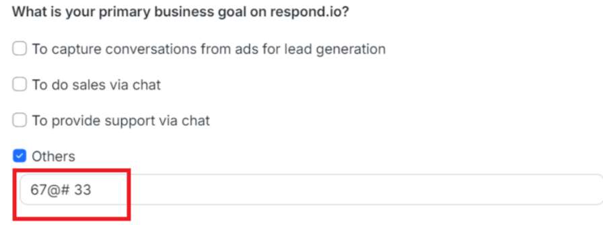

**Bug Title:**Keyboard Navigation Issue with Communication Channels

**Bug ID:** BUG-11  
**Reported By:** Syed Hassan Anwer  
**Date:** 2024-10-05

**Environment:**

* **Platform:** Web
* **OS:** Windows 10
* **Browser:** Google Chrome Version 117.0.5938.132 (Official Build) (64-bit)
* **Device:** Laptop (1366x768 screen resolution)

**Description:**The communication channel selection interface is not fully accessible using keyboard navigation. Users cannot select or deselect communication channels using the tab key or arrow keys. This makes the form difficult to use for users who rely on keyboard navigation, such as those with disabilities.

**Steps to Reproduce:**

1. Open the website on Google Chrome on Windows 10.
2. Navigate to the page with the communication channel selection interface.
3. Attempt to select or deselect communication channels using the tab key or arrow keys.

**Expected Result:**Users should be able to navigate between communication channels and select or deselect them using the tab key and arrow keys.

**Actual Result:**Keyboard navigation is not functional for selecting or deselecting communication channels.

**Severity:** low

**Priority:** low

**Annexure:**

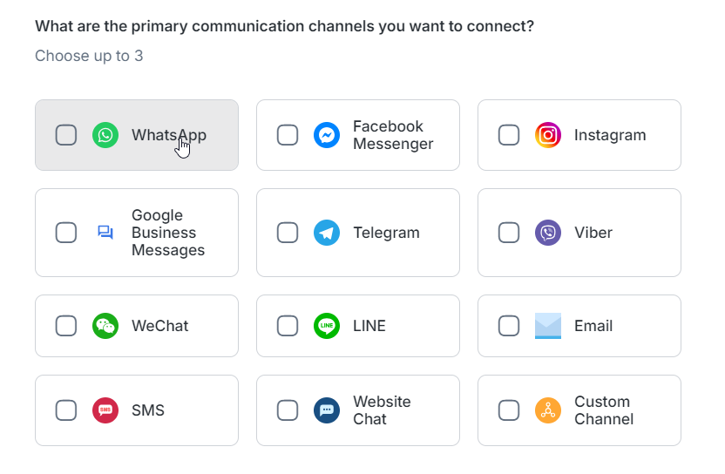

**Bug Title:**

Unauthorized Error on Language Change

**Bug ID:** BUG-12  
**Reported By:** Syed Hassan Anwer  
**Date:** 2024-10-05

**Environment:**

* **Platform:** Web
* **OS:** Windows 10
* **Browser:** Google Chrome Version 117.0.5938.132 (Official Build) (64-bit)
* **Device:** Laptop (1366x768 screen resolution)

**Description:**When a user attempts to change the language setting on the website, an unauthorized error is encountered. This means that the system is preventing the language change from taking place, likely due to a security or permission issue.

**Steps to Reproduce:**

1. Click on the language dropdown
2. Change the language to Arabic or Portuguese.

**Expected Result:**The language should change successfully, and the form should function as expected in the new language.

**Actual Result:**

The user might receive an unauthorized error.

**Severity:** High

**Priority:** High

**Annexure:**

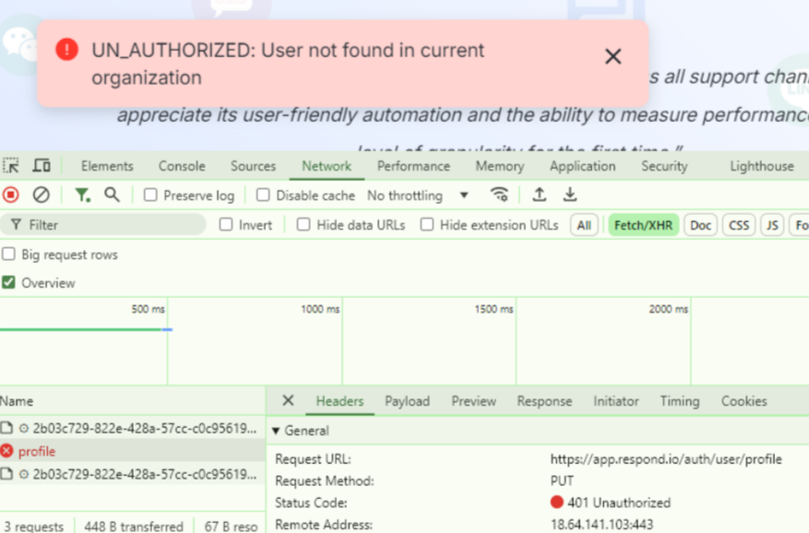

**Bug Title:**

Notifications Displayed in Bottom Left Corner

**Bug ID:** BUG-13  
**Reported By:** Syed Hassan Anwer  
**Date:** 2024-10-05

**Environment:**

* **Platform:** Web
* **OS:** Windows 10
* **Browser:** Google Chrome Version 117.0.5938.132 (Official Build) (64-bit)
* **Device:** Laptop (1366x768 screen resolution)

**Description:**  
Notifications are displayed in the bottom left corner of the screen, which may be less noticeable for users. This can result in users missing important messages or feedback.

**Steps to Reproduce:**

1. Open the application on Google Chrome.
2. Trigger a notification (e.g., by successfully registering or completing a form).
3. Observe the location of the notification.

**Expected Result:**  
Notifications should appear in a prominent location, such as the top right corner or a dedicated notification area, to ensure they are easily visible.

**Actual Result:**  
Notifications are displayed in the bottom left corner, which might be less noticeable to users.

**Severity:** Low  
**Priority:** Medium

**Annexure:**

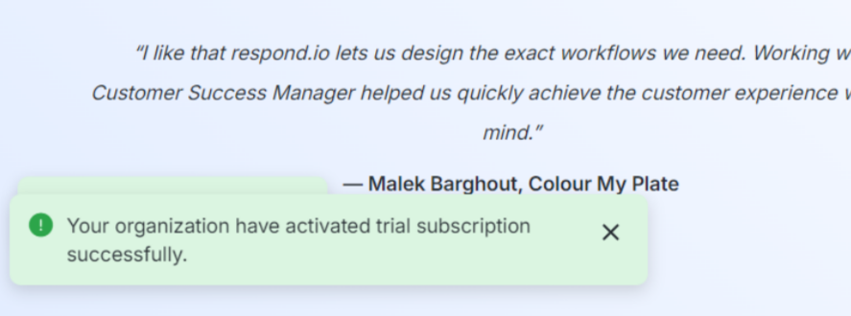

**Bug Title:**   
Contact Search Fails to Display Matching Results

**Bug ID:** BUG-14  
**Reported By:** Syed Hassan Anwer  
**Date:** 2024-10-06

**Environment:**

* Platform: Mobile App
* OS: iOS 16
* Device: iPhone 15 Pro
* App Version: 1.4.2

**Description:**  
When searching for contacts by typing the first letters of a contact's name, the search filter does not return any matching results. Even though a contact named "mj tester" is present, it does not appear when "mj" is entered into the search bar.

**Steps to Reproduce:**

1. Open the mobile app on iPhone 15 Pro.
2. Navigate to the Contacts section.
3. Add a contact with the name "mj tester".
4. In the search bar, type "mj".
5. Observe the search results.

**Expected Result:**  
The contact "mj tester" should be displayed in the search results when "mj" is entered.

**Actual Result:**  
The search does not return any matching results, even though "mj tester" is an existing contact.

**Severity:** Medium  
**Priority:** High

**Annexure:**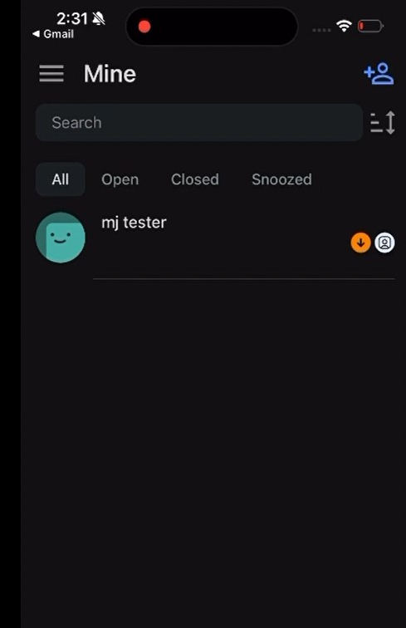

**Bug Title:**   
Language Name in Combo Box List is Cropped and Overlapping  
**Bug ID:** BUG-15  
**Reported By:** Syed Hassan Anwer  
**Date:** 2024-10-06

**Environment:**

* Platform: Mobile App
* OS: iOS 16
* Device: iPhone 15Pro
* App Version: 1.4.2

**Description:**  
In the language selection screen, some of the language names are cropped and overlapping with adjacent language names. This issue makes it difficult to read and select certain languages from the list.

**Steps to Reproduce:**

1. Open the mobile app on iPhone 15 Pro.
2. Navigate to the Profile section and select "Change Language".
3. Scroll through the list of languages and observe how certain names are cropped and overlap with other languages.

**Expected Result:**  
All language names should be fully visible and correctly aligned without any overlap.

**Actual Result:**  
Some language names are cropped, and there is overlap between adjacent names, making them unreadable.

**Severity:** Medium  
**Priority:** Medium

**Annexure:**

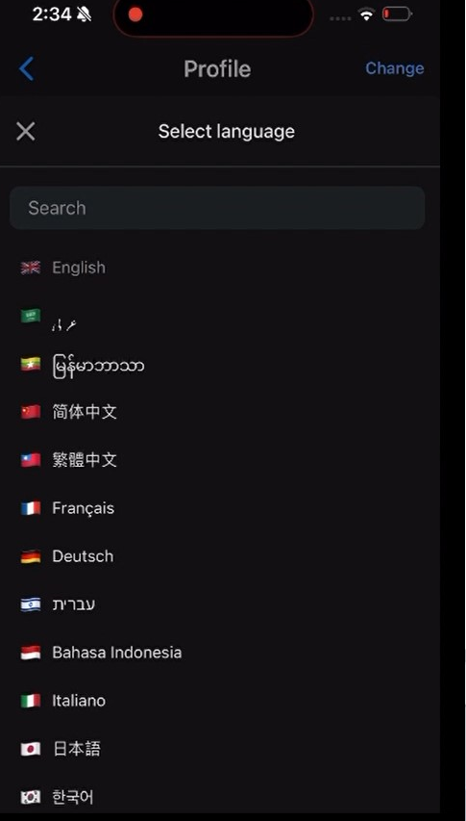

**Bug Title:** Language "PyccKᴎᴎ" Not Displayed in Search Filter  
**Bug ID:** BUG-16  
**Reported By:** Syed Hassan Anwer  
**Date:** 2024-10-06

**Environment:**

* **Platform:** Mobile App
* **OS:** iOS 16
* **Device:** iPhone 15 Pro
* **App Version:** 1.4.2

**Description:**When searching for the language "PyccKᴎᴎ" in the language selection screen, the search filter does not return the correct result when the user types "Pyc". This prevents users from quickly finding the language they are looking for.

**Steps to Reproduce:**

1. Open the mobile app on iPhone 15 Pro.
2. Navigate to the Profile section and select "Change Language".
3. In the search bar, type "Pyc".
4. Observe that the language "PyccKᴎᴎ" does not appear in the filtered results.

**Expected Result:**The language "PyccKᴎᴎ" should be displayed in the filtered results when the user types "Pyc".

**Actual Result:**The language "PyccKᴎᴎ" does not appear in the filtered results despite it being available in the language list.

**Severity:** Medium  
**Priority:** High

**Annexure:**

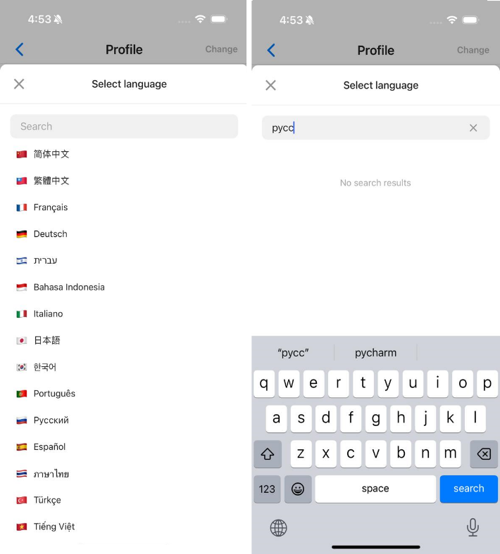

**Bug Title:**Error: "Something Went Wrong" when Logging into Mobile App After Signup on Web

**Bug ID:** BUG-17

**Reported By:** Syed Hassan Anwer

**Date:** 2024-10-06

**Environment:**

* **Platform:** Mobile App
* **OS:** iOS 16
* **Device:** iPhone 15 Pro
* **App Version:** 2.5.1
* **Web Browser:** Chrome 117 (web sign-up)

**Description:**After a user sign up on the web platform without completing the onboarding process, and then logs into the mobile app using the same credentials, the user encounters an error stating, "Something went wrong." This prevents users from accessing the app, creating a frustrating experience.

**Steps to Reproduce:**

1. Open the web platform in Chrome 117.
2. Sign up using a valid email and password, but do not complete the onboarding process.
3. Open the mobile app on iOS device.
4. Log in using the same credentials created on the web platform.
5. Observe the error message "Something went wrong."

**Expected Result:**The user should be able to log in successfully on the mobile app and continue the onboarding process or access the app features.

**Actual Result:**The user sees the error "Something went wrong" and is unable to log in or proceed further.

**Severity:** High

**Priority:** High

**Annexure:**

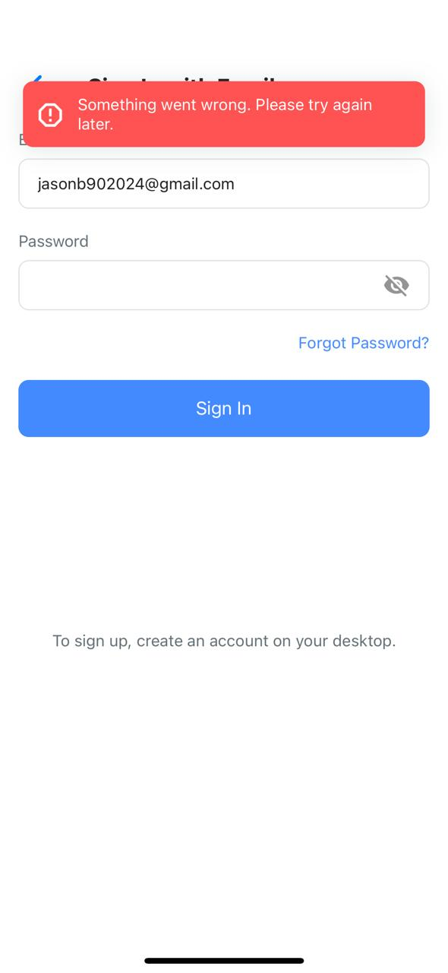

**Mobile Application Test Cases**

* Verify, that in the "Connect Channels and Invite Your Team" step, channels can be linked.
* Verify, that in the "Connect Channels and Invite Your Team" step, team members can be invited via email.
* Verify, that in the "Automate Your Communication with Workflows" step, the Workflow builder functions correctly on various mobile devices.
* Verify, that in the "Reach Potential Customers with Broadcasts" step, at least one broadcast-supported channel can be selected, and a broadcast can be successfully added.
* Verify, that the onboarding form’s dismiss option only appears after all steps are completed.
* Verify, that when the dismiss button is clicked, the onboarding form icon is removed from the UI.
* Verify search result give accurate results as per the entered data
* Verify there should be no overlapping or text cropping in application UI
* Verify, that the organization setup form appears when the user signs up and logs in for the first time.
* Verify, that the organization setup form is shown repeatedly until the user completes it.
* Verify, that all fields on the organization setup form are identical to the web app version.
* Verify, that an organization can be added successfully when all required form fields are filled.
* Verify, that the trial period automatically activates after the organization is successfully added, and a confirmation message is displayed.
* Verify that a welcome video is shown after adding the organization and can be played.
* Verify, that the welcome video includes an option to be skipped.
* Verify, that a Workspace is created automatically by default after the organization is added.
* Verify, that the user is directed to the onboarding form immediately after the organization is added.
* Verify that each step of the onboarding process is accurately displayed with the ability to navigate between them.
* Verify, that after completing each step in the onboarding form, it is marked as completed.
* Verify, user signed up from web is able to login on mobile as well
* Verify workspaces added from web app is shown on mobile, vice versa
* Verify user should be able to login using magic link
* Verify that the "Sign-In with Email & Password" button is clickable.
* Verify that the "Sign-In with Magic Link" button is clickable.
* Verify that the "Sign-In with Single Sign-On (SSO)" button is clickable.
* Verify that entering a valid email and password allows the user to log in.
* Verify that the "Forgot Password?" link navigates to the password recovery screen.
* Verify that the "First Name" field accepts text input.
* Verify that the "Last Name" field accepts text input.
* Verify that the "Phone" field allows entering a valid phone number.
* Verify that the email field accepts valid email addresses.
* Verify that the "Assignee" field allows selecting an assignee.
* Verify that the "Tags" field allows adding tags to the contact.
* Verify that the "Save" button is enabled after entering valid contact details.
* Verify that the "Select Language" screen displays a list of available languages.
* Verify that the user can search for a language using the search bar.
* Verify that selecting a language updates the app language correctly.
* Verify that the user's profile picture and email are displayed correctly.
* Verify that tapping "Set yourself as busy" updates the user status to "busy."
* Verify that the "Change workspace" option navigates to the workspace selection screen.
* Verify that the "Update notifications" option allows updating notification preferences.
* Verify that the "Change password" option navigates to the change password screen.
* Verify that the "Change appearance" option allows switching between appearance modes.
* Verify that the "Report issue" option opens the issue reporting screen.
* Verify that the "Log out" button logs the user out of the app.
* Verify that the profile picture can be updated by tapping "Change Profile Picture."
* Verify that the "First Name" and "Last Name" fields allow editing of the user's name.
* Verify that the email field displays the correct user email and allows updates.
* Verify that changing the language updates the app's language accordingly.
* Verify that the user can rate the mobile app by selecting a star rating (1-5).
* Verify that submitting a rating saves the user's feedback successfully.
* Verify that the search bar allows users to search contacts by name.
* Verify that the search results display relevant contacts.
* Verify that the "Contacts," "Messages," and "Comments" tabs switch views accordingly.
* Verify that opening a message from the list displays the conversation.
* Verify that the "All" tab shows all types of messages (Open, Closed, Snoozed).
* Verify that the "Open" tab only displays active conversations.
* Verify that the user can snooze or close conversations from the list.
* Verify that searching for a contact filters the message list accordingly.

**Mobile Application Negative Test Cases**

**1. Login Screen**

* Verify that logging in with an invalid email format (e.g., "abc@") displays an appropriate error message.
* Verify that logging in with an incorrect password shows a "Wrong Password" error.
* Verify that leaving the email or password field blank and attempting to log in shows an error.
* Verify that using an expired "Magic Link" prevents login and shows an appropriate error message.
* Verify that logging in with a deactivated user account shows a "User is deactivated" error.
* Verify that trying to log in without network connectivity displays a "No internet connection" error.

**2. Add Contact Screen**

* Verify that attempting to save a contact without filling out any fields shows an error.
* Verify that entering an invalid phone number format shows a validation error.
* Verify that entering an invalid email format prevents the contact from being saved.
* Verify that leaving the "First Name" and "Last Name" fields blank and trying to save results in an error.
* Verify that entering non-numeric characters in the phone number field shows an error message.
* Verify that attempting to assign a contact to a nonexistent assignee shows an error.
* Verify that attempting to save a duplicate contact with the same email/phone number shows an error.

**3. Profile Language Selection**

* Verify that selecting an unsupported language does not apply the language change (if applicable).
* Verify that attempting to change the language without internet connectivity results in a failure to update.
* Verify that entering invalid characters in the search bar does not crash the app.

**4. Settings Screen**

* Verify that setting yourself as busy fails with an error if there is no network connection.
* Verify that changing the workspace to a nonexistent or deactivated workspace shows an error message.
* Verify that trying to update notifications without the required permission results in a failure.
* Verify that trying to change the password without entering the current password results in an error.
* Verify that entering an invalid new password format (e.g., less than 6 characters) shows an error.
* Verify that changing the appearance to a non-existent mode result in a failure.
* Verify that attempting to report an issue without a valid internet connection result in an error.
* Verify that attempting to log out without network connectivity fails and shows an error.

**5. Profile Edit Screen**

* Verify that trying to update the profile picture with an unsupported file format fails.
* Verify that attempting to leave the "First Name" or "Last Name" fields blank and save the profile shows an error.
* Verify that entering an invalid email format and attempting to save the profile results in an error.
* Verify that trying to change the language without proper permissions (if any) fails and shows an error.
* Verify that saving the profile without network connectivity fails and shows an error.

**6. Rating Screen**

* Verify that trying to submit a rating without selecting any stars shows an error.
* Verify that submitting a rating without network connectivity results in a failure.
* Verify that trying to select more than 5 stars (if UI bug exists) causes the submission to fail.

**7. Search and Message Screen**

* Verify that entering special characters or invalid input in the search bar does not return any results.
* Verify that searching for a contact that does not exist shows "No results found."
* Verify that trying to view messages without network connectivity fails to load conversations.
* Verify that attempting to switch tabs (Contacts, Messages, Comments) without internet fails and shows an error.
* Verify that trying to load messages for a deleted contact results in a failure.

**8. All Messages Screen**

* Verify that searching for a conversation that does not exist returns no results.
* Verify that attempting to snooze or close a conversation without permission results in an error.
* Verify that marking an already closed conversation as closed again shows an error or fails.
* Verify that trying to load messages when there are no internet results in a failure to fetch conversations.
* Verify that attempting to mark multiple messages as closed or snoozed at the same time results in an error.